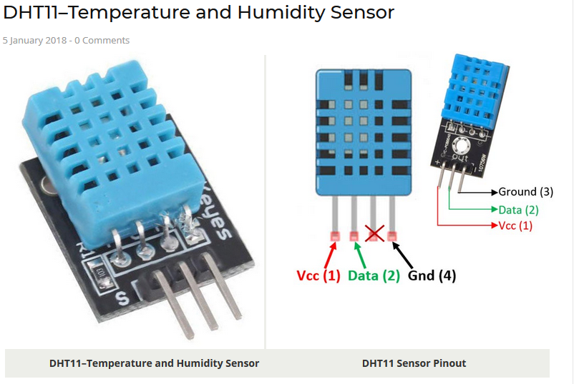
1. DHT11 Sensor :

LCD Screen (16x2) :
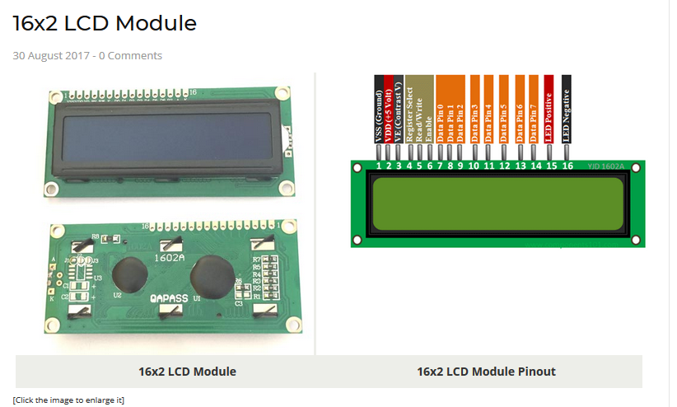
3. I^2C Protocol for LCD Screen.
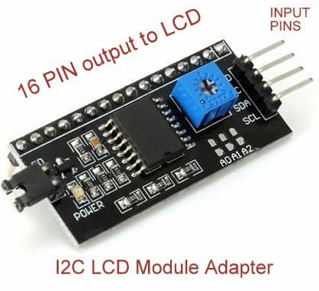

DHT11 Source => https://components101.com/dht11-temperature-sensor
LCD Screen Source => https://components101.com/16x2-lcd-pinout-datasheet
I2C Protocol Module => https://www.homemade-circuits.com/introduction-i2c-lcd-adapter-module/

